**Experiment No. 09**

* 1. **Experiment Name**

Simulation on bi-directional hysteresis control of grid connected H- bridge and battery with controlled DC linked voltage

* 1. **Objectives**
* To develop and study a H bridge inverter using Simulink
* To get familiarize with the Simulink platform and Simulink library
* To use the Simulink platform to construct and analyze a bi-directional hysteresis control of grid connected H bridge inverter
  1. **Apparatus**
* Simulink
  1. 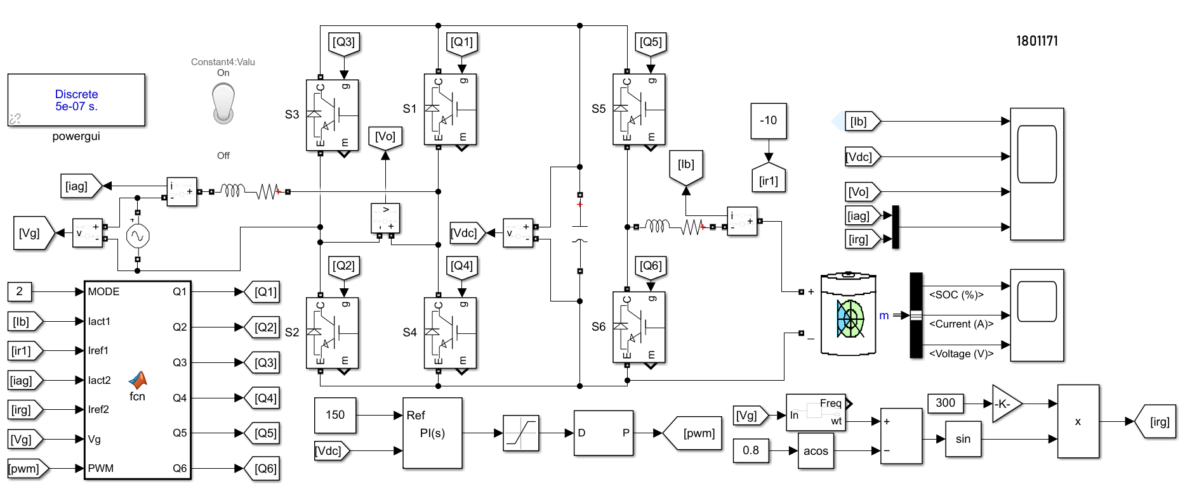**Simulink Block Diagram & Waveform**

Fig.9.1: Block diagram of bi-directional hysteresis control of grid connected H- bridge and battery with controlled DC linked voltage

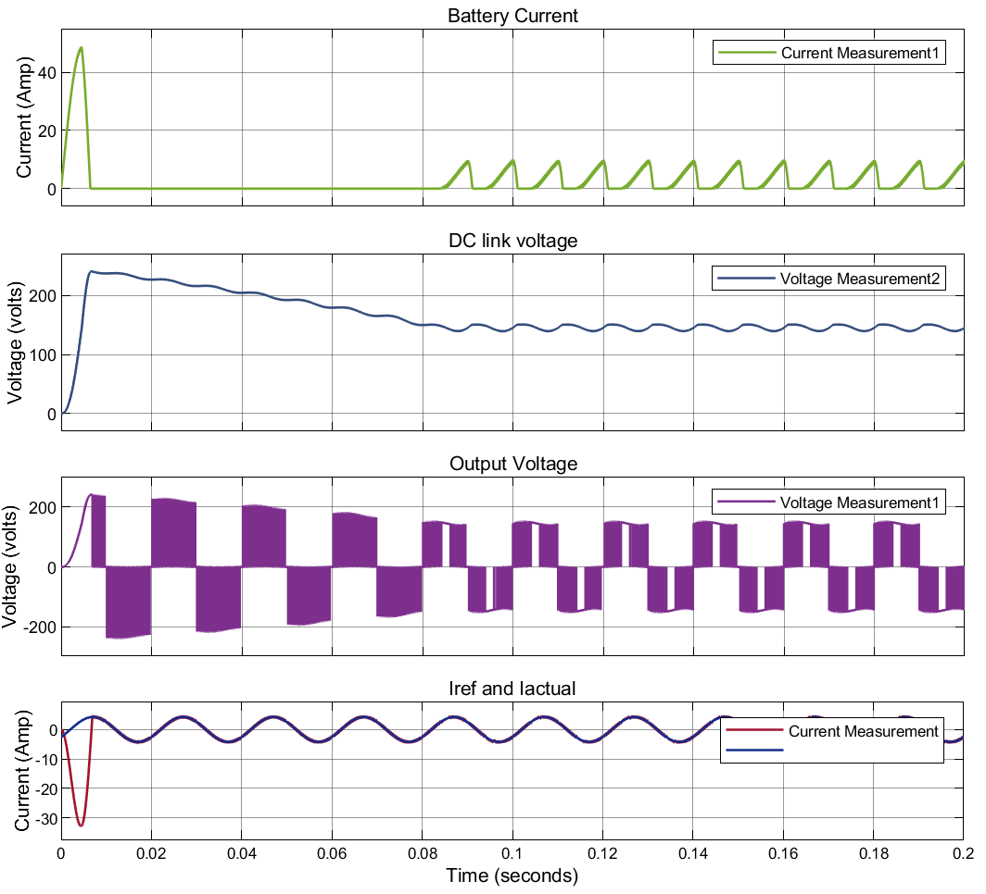

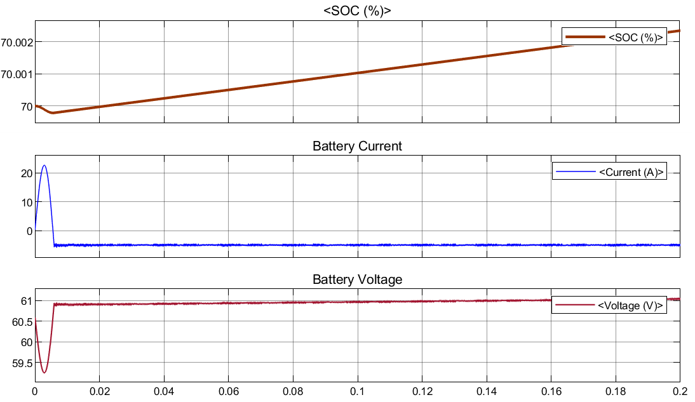

Fig.9.2: Waveform of bi-directional hysteresis control of grid connected H- bridge and battery with controlled DC linked voltage

**MATLAB Code**

function [Q1,Q2,Q3,Q4,Q5,Q6] = fcn(MODE,Iact1,Iref1,Iact2,Iref2,Vg,PWM)

persistent S1; if isempty(S1);S1=0;end

persistent S2; if isempty(S2);S2=0;end

persistent S3; if isempty(S3);S3=0;end

persistent S4; if isempty(S4);S4=0;end

persistent S5; if isempty(S5);S5=1;end

persistent S6; if isempty(S6);S6=0;end

if MODE==1

S1=0;S2=0;S3=0;S4=0;S6=0;

e1=Iact1-Iref1;

d1=0.5;

if e1>=d1

S5=1;

elseif e1<=-d1

S5=0;

else S5=S5;

end

else MODE==2

d2=0.5;

S6=PWM;

S5=0;

e2=Iact2-Iref2;

if Vg>=0

if e2<=-d2

S1=1;S2=1;S3=0;S4=0;

elseif e2>=d2

S1=1;S2=0;S3=1;S4=0;

else

S1 = S1;S2=S2;S3=S3;S4=S4;

end

else

if e2<=-d2

S1=0;S2=1;S3=0;S4=1;

elseif e2>=d2

S1=0;S2=0;S3=1;S4=1;

else

S1 = S1;S2=S2;S3=S3;S4=S4;

end

end

end

Q1=S1; Q2=S2; Q3=S3; Q4=S4;Q5=S5;Q6=S6;

end

* 1. **Discussion & Conclusion**

This experiment thoroughly investigated hysteresis control of grid connected H bridge system and battery with controlled DC linked voltage. For this system, we utilized connection and value of parameter according to our preference. Similarly, for Hysteresis control inverter, we used necessary tool according to our requirements. Thus, desired output was observed and the simulation was a success.